1. **Screenshot of shell script**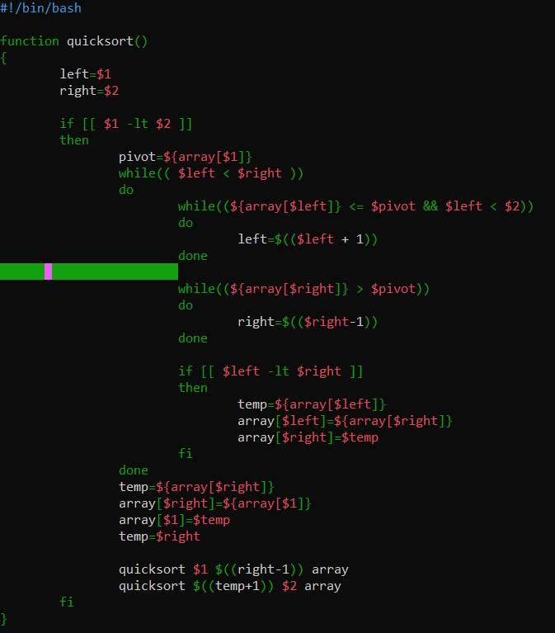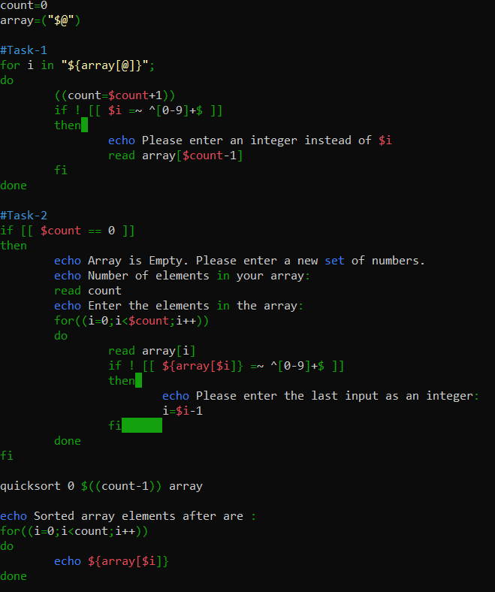
2. **Screenshot of successful sort**

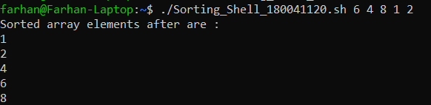

1. **Screenshot of an execution considering “Special Case – i”**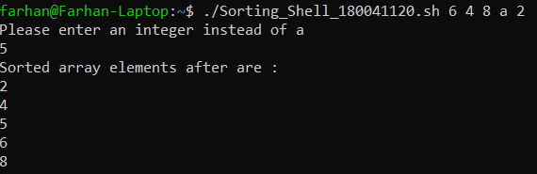
2. **Screenshot of an execution considering “Special Case – ii”**

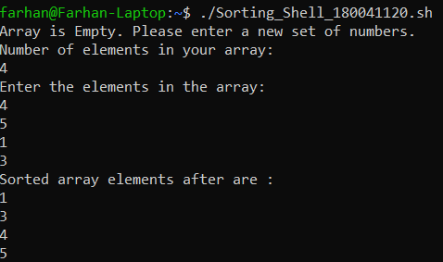

1. **Screenshot of an execution considering both “Special Case – i” & “Special Case – ii”**

